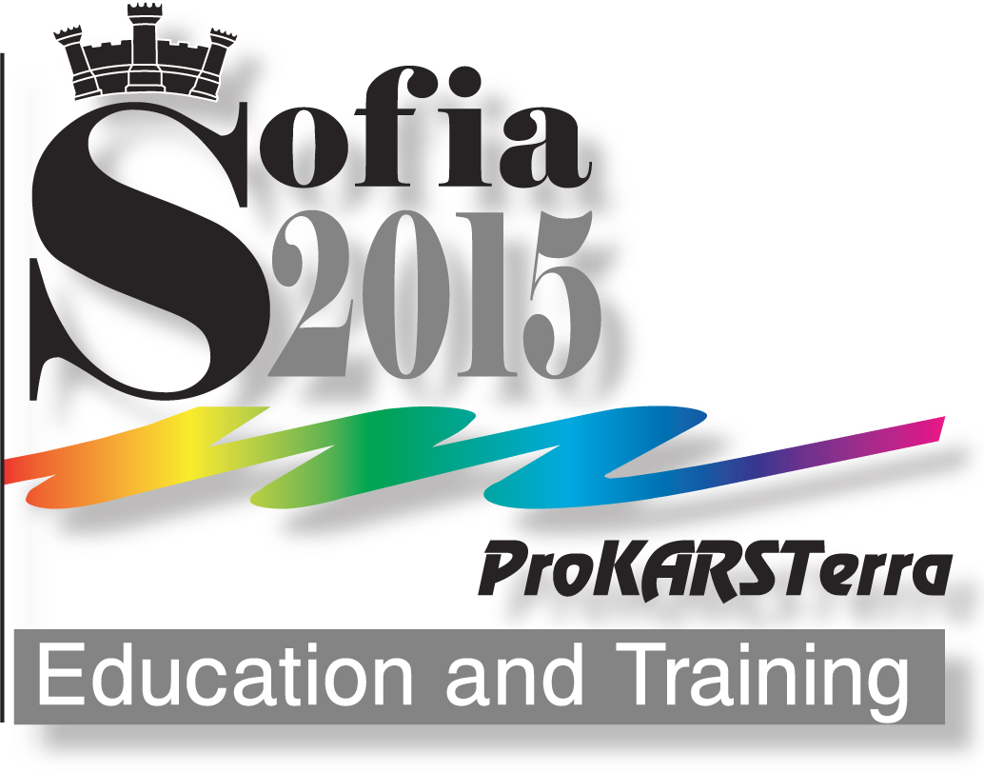 | International Scientific-practical conference  PROTECTED KARST TERRITORIES – EDUCATION AND TRAINING  (23-26 September 2015, Sofia)  REGISTRATION FORM  (Deadline for submission: 6 September 2015)

Name ............................................................................................ Family name ........................................................................

Work position ……………………………….. Academic degree .............................................................................……….

Name for the badge (if different from the indicated ………………….……………………………………….

Organization/Company .................................................................................................................................................................................….

City .............................................................................. Country......................................................................................................

Statute of participation (please mark the respective form):
 Regular participant  Student/Doctor student  Retiree
 Company representative ………………………………………………………………………………………………………………………
(please indicate the company – name and registration, headquarters, country)

Form of participation (the forms of participation marked can be more than one):
With paper/s:(please indicate the number on the respective place):

 oral presentation;  multimedia presentation;  poster.
Listener 
With corporate presentation 
In the ProKARSTerra’2015 exhibition
 Book  Photograph/s  Movie  Other information materials
 Picture/s paintings  Art installation  Specialized equipment.

Paper/Poster
Full title:
- ...................................................................................................................................................………...........

- ..........................................................................................................................................................................

.........................................................................................................................................................................
Author/s:
- ....................................................................................................................................................……………..

- ..........................................................................................................................................................................

Participation in activities of the Conference:

 23.09. Opening ceremony
 23.09. Plenary session
 23.09. Announcement of the Competition results and Opening of exhibition

 24 и 26.09. Section meetings
 25.09. One day thematic excursion

26.09. Round tables:
               Karstologic Olympiad  International Year of karst and caves

 26.09. Final discussion
 26.09. Gala dinner
 23-26.09. Cultural program in Sofia

 27-30.09. Excursion after the conference (Karst pearls in the West Rhodopy, Bulgaria)

Fees paid (For details please see: http://prokarstterra.bas.bg/forum2015/fees.html ):

Sum paid Document number Payment at the site
Registration tax Early payment Late payment
before 13 July 2015 after 13 July .2015

Participant with paper/poster
- Standard fee 135 € 180 € .............. .......................................... 
- Reduced fee 75 € 100 € .............. .......................................... 
Participant without paper
- Standard fee 75 € 100 € .............. ........................................... 
- Reduced fee 45 € 60 € ……….. ........................................... 

Gala dinner 15 € ……….. ........................................... 
Excursion after the Conference:
- Single room accommodation 200 € ..……… …………………………… 
- Double room accommodation 180 € ……….. .…………………………... 

Total: ............... 

Special food requirements

 No  Vegetarian  Other (please specify) .....................................................................................…
..................................................................................................................................................................................................................................................

Other requirements (please specify): ............................................................................…………………………………………………………
................................................................................................................................................................................……

Date ………………..……… Signature..............................................

Please fill in your Registration form and send it by E-mail: forum2015@prokarstterra.bas.bg or forum2015@abv.bg.

